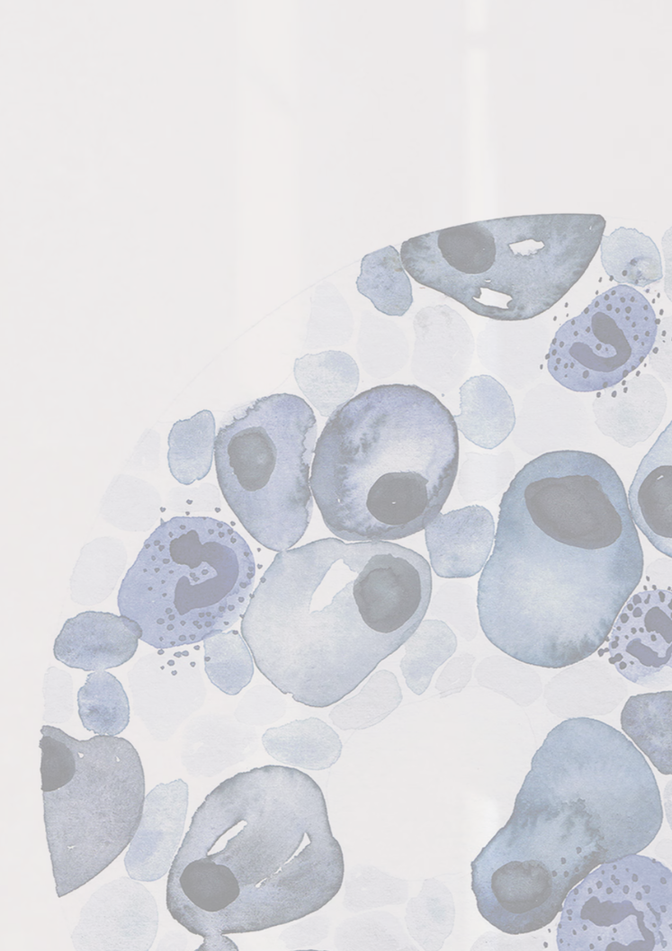

PhD program in Medical Biotechnologies
(Coordinator Prof. Francesco Iannelli)

School of Specialization in Pathological Anatomy
(Coordinator Prof. Cristiana Bellan)

Seminar notice

Prof. German Ott

Department of Clinical Pathology, University of Wurzburg, Wurzburg Germany

The High Grade B-cell Lymphomas - A Heterogenous and Challenging Category
Siena, 23 February 2026, 12.00 – 13.00 a.m.
Aula 10, Centro Didattico Policlinico “Le Scotte”
Google meet: meet.google.com/vmm-eeid-bna

